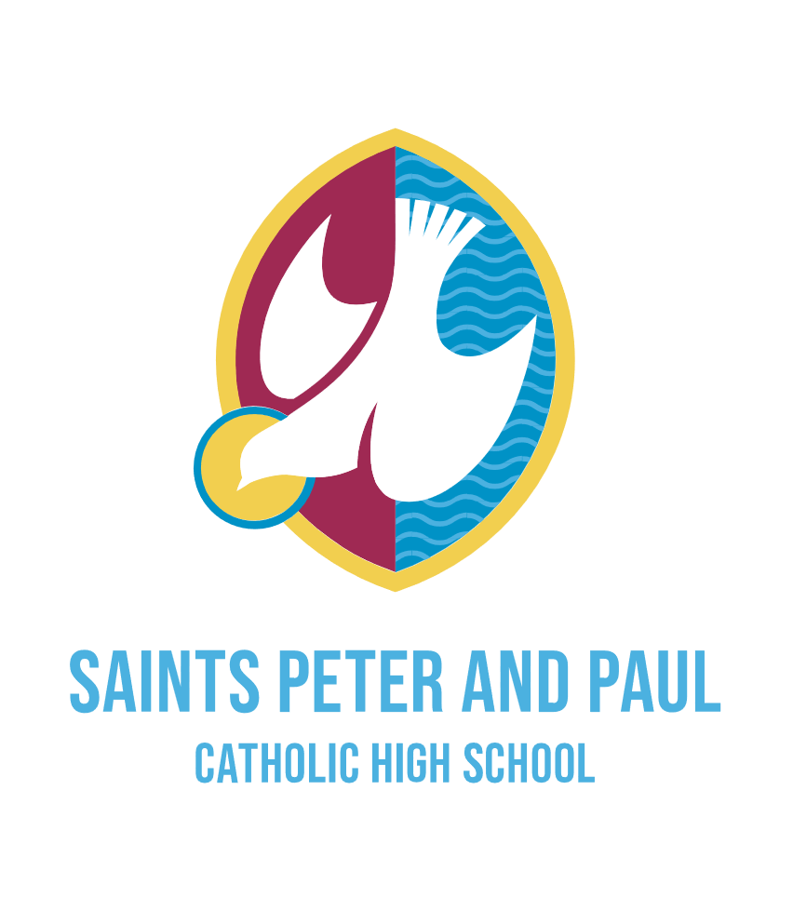

**Job Advert**

Teaching Assistant

HBC 3 £20,777 – 21,107 Actual

Term Time Only: 37 hours per week

An exciting opportunity has arisen for a proactive and motivated individual to join our school community, who will contribute towards our mission, to be 'an inclusive community of excellence and opportunity'.

We are proud of our open, collaborative, supportive and forward-thinking culture.

Our SEND team is at an exciting point in its development, which includes the recent opening of a specialist ASC Resource Base. Together we provide the support that students need to access the curriculum and to thrive in their learning environment.

Like us, you will be dynamic, creative and hardworking. You will have a strong desire to positively impact upon students’ learning.

We offer a comprehensive induction and encourage all of our staff to be ambitious for their futures.

Prospective applicants are most welcome to arrange to visit by emailing [admin@saintspeterandpaul.halton.sch.uk](mailto:admin@saintspeterandpaul.halton.sch.uk)

Further information and an application form can be found on the school website: [Saints Peter and Paul Catholic High School | Vacancies](https://www.saintspeterandpaul.halton.sch.uk/vacancies/)

Please send completed application forms to: [recruitment@saintspeterandpaul.halton.sch.uk](mailto:recruitment@saintspeterandpaul.halton.sch.uk)

Strictly no CVs. CES Application forms only with supporting statement.

Closing date for applications is 9am Wednesday 6th August 2025.

Saints Peter and Paul Catholic High School is committed to safeguarding and promoting the welfare of students and the post is subject to an enhanced DBS check and references.