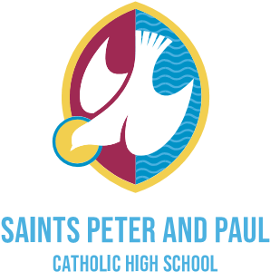

**Faith guides us to inspire every student to be the best they can be.**

**ADDITIONAL INFORMATION TO SUPPORT APPLICATION FOR ENTRY FOR SCHOOL YEAR**

# Starting: September 2026

SURNAME: ..........................................................................................................................

STUDENT'S CHRISTIAN

NAMES:.............................................................................................

STUDENT'S DATE OF BIRTH: ........../ ........../ ..........

ADDRESS: .......................................................................................................

........................................................................................................

.................................................. POST CODE: .................................

HOME TELEPHONE NUMBER:

.........................................................................................................

WORK TELEPHONE NUMBER(S): ......................................................

.................................................

(FATHER) (MOTHER)

# RELIGION: It is very important to provide the following information as it could have a significant impact on your application

***If your child is Roman Catholic, please:***

 Supply a copy or original baptismal certificate/proof of baptism

 state in which Parish you live

..................................................................................................................

 state whether your child has made his/her First Communion? YES / NO

***If your child is not a baptised Roman Catholic* please** state here your reasons for choosing this Catholic school for his / her education and provide a letter of support from your local minister or copy of baptismal certificate.

...................................................................................................................................................

.................................…………………………………………………………………………………

…………………………………………………………………………………………………………… ………………………………………………………………………….

# NAMES OF ANY BROTHERS/SISTERS PRESENTLY ATTENDING SAINTS PETER AND PAUL CATHOLIC HIGH SCHOOL

...................................................................................................................................................

.......................................................

WE/I recognise and support the spiritual, academic and pastoral aims of the school as outlined in the school prospectus.

**SIGNED.........................................................................................................Parent/Guardian**

**COMPLETION OF THIS FORM DOES NOT CONFIRM A PLACE AT SAINTS PETER AND PAUL CATHOLIC COLLEGE**

# PLEASE COMPLETE AND RETURN BY 31 OCTOBER 2025